# Unit 7 - Assignment

This assignment will reinforce your knowledge of the following areas:

* Working with ADO.net provider objects
* Working with a DataSet
* Working with the DataGridView control

## Introduction

The last phase of the project will require you to modify the existing functionality of the Sales Quote form. Data will no longer be retrieved using the data.dll, and will be retrieved from a database. A new form is added to manage vehicle data.

**PROGRAMMER TIP**: It is highly recommended that you backup your solution prior to making major modifications to an existing code set.

## Resources

To complete this phase of the project you will need to download the assignment file(s) from [here](https://thethirstycoder.gitlab.io/adev-2005-learn/unit_7/downloads/unit_7_assignment_download.zip).

## Requirements

Update the launcher form so that clicking the Vehicle menu item shows an instance of the Vehicle Data form.

### Vehicle Data Form

The vehicle data form displays vehicle data from the database.

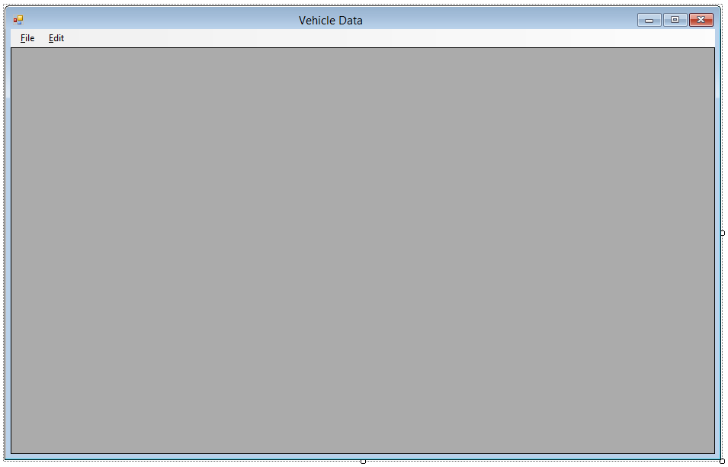

#### **Initial State**

* Menu strip docked to the top of the form.
  + Save menu item disabled
  + Delete menu item disabled
* Data Grid View docked to the center of the form.
* Title of the form is Vehicle Data.
* Start position of the form is in the middle of the screen.

#### **Menu Strip Design and Functionality**

* File
  + Save (Ctrl+S)
  + [Separator Line]
  + Close (Ctrl+W)
* Edit
  + Delete (Del)

**Note**: The menu strip items must be named correctly, include keyboard accessors and keyboard shortcuts as outlined (in parentheses) above. Do not include the parentheses for the keyboard shortcuts.

#### **Save Menu Item**

When the save menu item is clicked, all data changes are saved to the database.

#### **Close Menu Item**

When the close menu item is clicked, the form is closed.

#### **Delete Menu Item**

When the delete menu item is clicked, the selected row is removed from the DataGridView and deleted from the database.

#### **Data Grid View Initial State**

* Disable the ability for users to delete rows.
* Disable the ability for users to resize rows.
* Auto size columns using Fill mode.
* Disable the ability for users to select multiple rows.

#### **Construction**

When an instance of the vehicle data form is constructed, all vehicle data from the VehicleStock table is retrieved. When any exception is thrown during construction, do not show the form. Show a dialog box with the following information:

* Text: Unable to load vehicle data.
* Caption: Data Load Error
* Buttons: Ok
* Icon: Error

When vehicle data is successfully retrieval from the database:

* Display the vehicle data in the Data Grid View control.
* Hide the “ID” column in the Data Grid View.

#### **Data Grid View Selection Changed**

When a selection change is made to the data grid view and the current row is selected (which is not a new row), enable the delete menu item. If the current row is not selected or is a new row, disable the delete menu item.

**Note**: To select a row in a data grid view, click the row header cell.

#### **Data Grid View Cell Value Changed**

When a cell value has changed in the data grid view, apply the Data Grid View changes to the data source (DataTable). If the data was changed:

* Set the title of the form to “* Vehicle Data”. The asterisk indicates to the user that a change was made to the data.
* Enable the save menu item.

#### **Delete Menu Item Clicked**

When the delete menu item is clicked, show a dialog box with the following information:

* Text: Are you sure you want to permanently delete stock item ?
* Caption: Delete Stock Item
* Buttons: Yes and No
* Icon: Warning
* Default button: No

If the user chooses “No”, no action will take place. If the user chooses “Yes”, remove the row from the data grid view and update the database. The delete menu item is disabled after a deletion. When any exception occurs while updating the database, show a dialog box with the following information:

* Text: An error occurred while deleting the selected vehicle.
* Caption: Deletion Error
* Buttons: Ok
* Icon: Error

#### **Save Menu Item Clicked**

When the save menu item is clicked, attempt to save the changes to the database. When any exception occurs, show a dialog box with the following information:

* Text: An error occurred while saving the changes to the vehicle data.
* Caption: Save Error
* Buttons: Ok
* Icon: Error

On a successful save, set the title of the form back to “Vehicle Data” and disable the save button.

#### **Form Closing**

Before the form is closed and there has been changes to the data, display a dialog box with the following information:

* Text: Do you wish to save the changes?
* Caption: Save
* Buttons: Yes, No, and Cancel
* Icon: Warning
* Default button: Cancel

If the user chooses “Cancel”, prevent the form from closing. If the user chooses “No”, allow the form to close. If the user chooses “Yes”, attempt to save the changes to the database. If any exception occurs, show a dialog box with the following information:

* Text: An error occurred while saving the changes. Do you still wish to close this window?
* Caption: Save Error
* Buttons: Yes and No
* Icon: Error
* Default button: No

If the user chooses “Yes”, close the form. If the user chooses “No”, prevent the form from closing.

### Update Sales Quote Form

Update the sales quote form such that it uses vehicle data from the database to populate the vehicle combobox. The form’s functionality will remain the same with the additions listed below.

#### **Construction**

When an instance of the sales quote form is constructed, retrieve all vehicles that are not sold (SoldBy field is 0) from the VehicleStock table in the database.

When any exception occurs during construction, do not show the form. Show a dialog box with the following information:

* Text: Unable to load vehicle data.
* Caption: Data Load Error
* Buttons: Ok
* Icon: Error

If no data is retrieved (0 rows returned), show a dialog box with the following information:

* Text: There are no vehicles in stock.
* Caption: Sales Quote Data
* Buttons: Ok
* Icon: Information

## Programming Requirements

Your program must use data binding to populate controls with Vehicle data. In some special cases, data binding may not make sense, and thus output will be generated another way.

Your program must use the provided database (AMDatabase.mdb).

## Testing

Ensure the application is fully tested before user acceptance testing (UAT). Developing a list of test cases prior to testing will help eliminate missing tests.

Unit testing is not required, but is something you can do with form classes.